**Core Java Assignment-3**

**Assignment on String Class**

Q.1

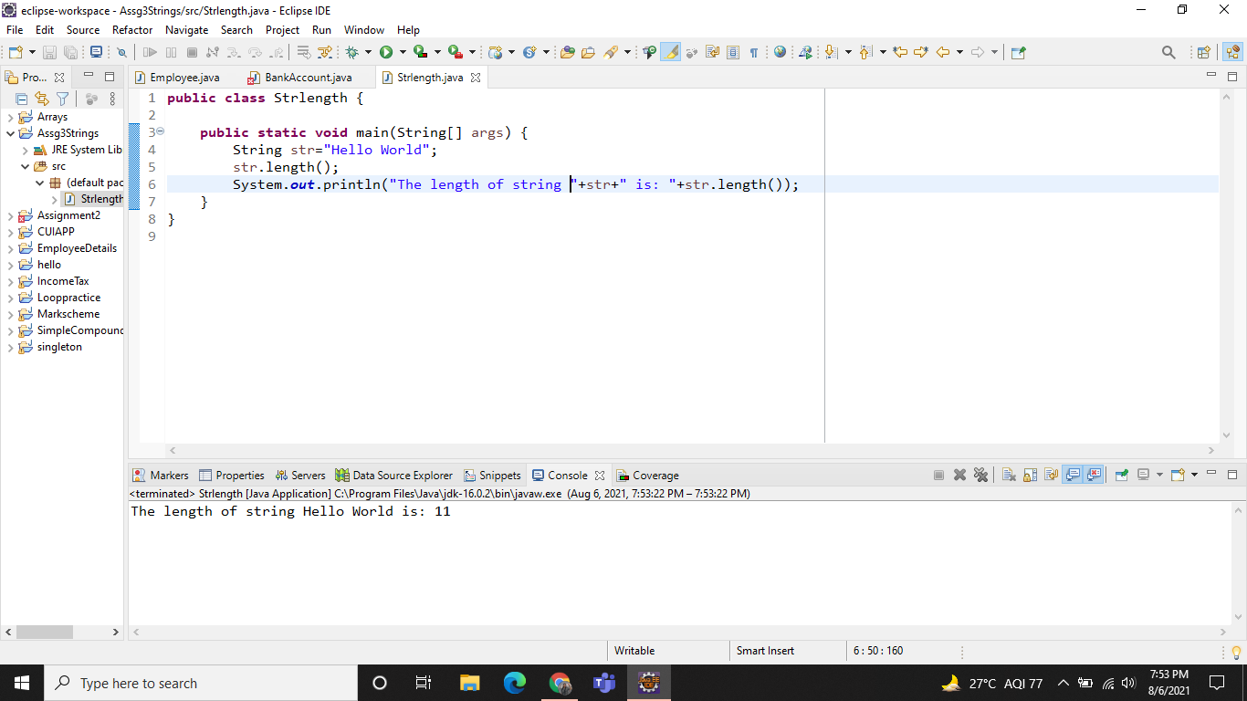

Q.2

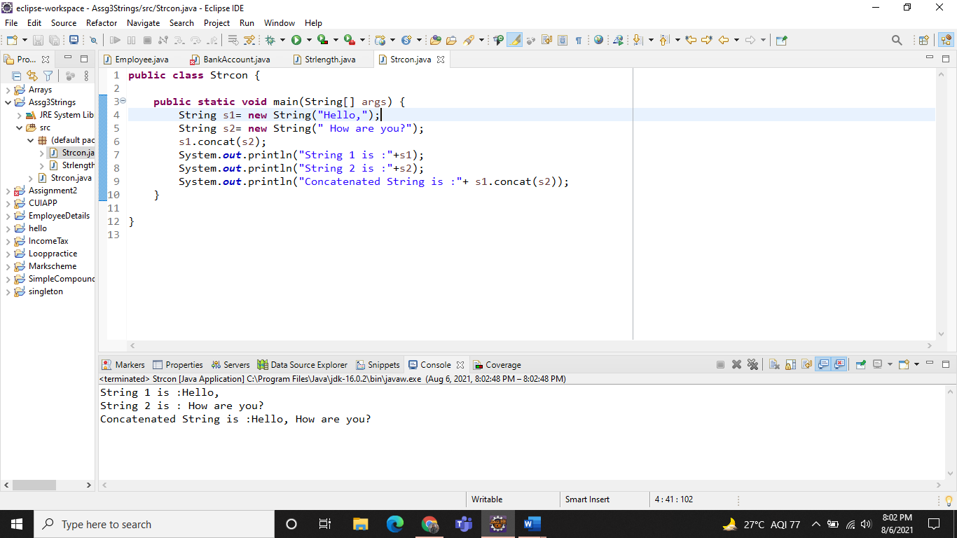

Q.3

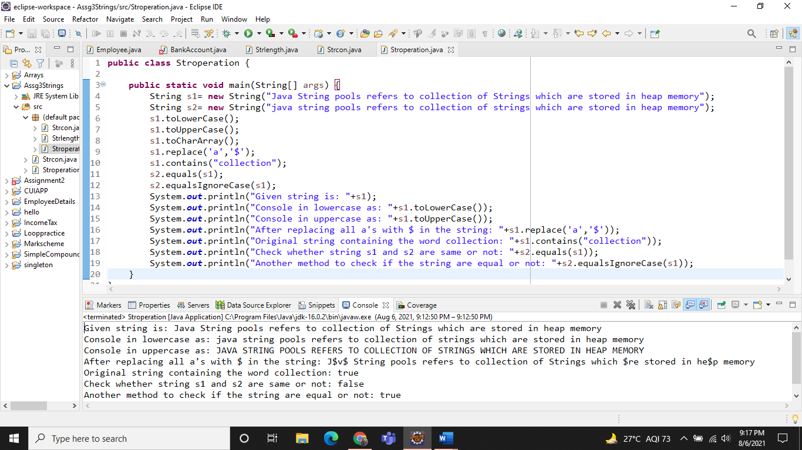

**Assignment on StringBuffer Class**

Q.1,2,3

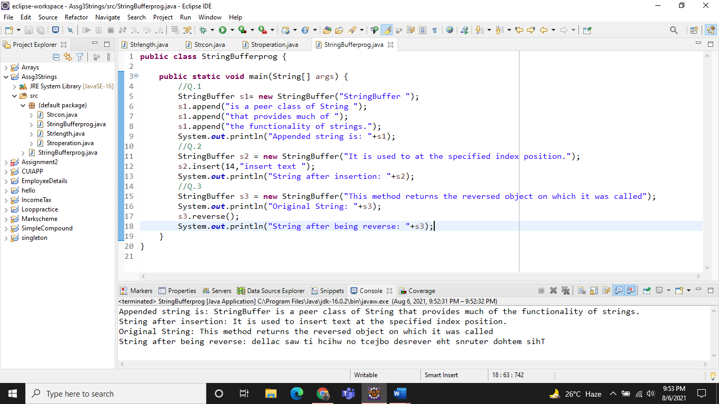

**Assignment on StringBuilder Class**

